SOP for Password Change on Cisco Devices

- Login on the Network Cisco Devices.

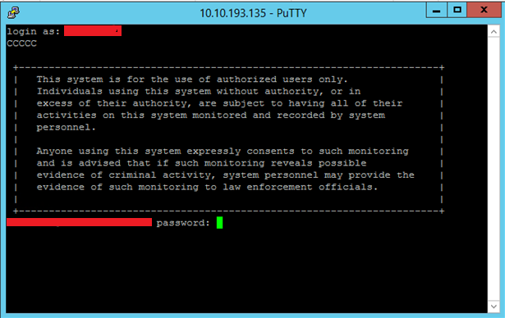

- After login and Password enter into config mode to change the password.

- Use the below command to change the password of particular user.

- We have multiple users in Network team so specific user ID’s have been created. Every user has to change his own password.

